***PAAREES PERFUMES***

***Christian Diors***

***FOR WOMEN***

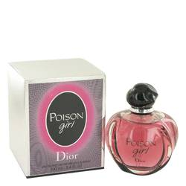

# *Poison Girl*

***Description:***

Poison Girl by Christian Dior Perfume. Poison Girl is an intoxicating, sensual, and floral fragrance that was released in 2016 by Christian Dior. Top notes of Sicilian bitter orange combine perfectly with the heart notes of grasse and damask rose. Base notes include earthy, woody scents such as vanilla, sandalwood, almond, tofu balm, and tonka bean. This fragrance was designed for women and is ideal to wear day or night, whenever the feeling to be a little risqué and scandalous arises. This reddish-pink perfume is bottled in a round, almost apple-shaped flagon, evoking the poisonous apple from fairy tales. This perfume was created with the help of master perfumer Francois Demachy.  
  
Christian Dior is a French fashion designer whose name is synonymous with high fashion and luxury. Although Christian Dior passed away in 1957, the Dior name lives on with haute couture designs as well as fragrances, personal care products, and ready-to-wear clothing for men and women.